

**SR. SECONDARY SCHOOL**

**Affiliated to CBSE up to 10 + 2**

**(Affiliation No. 330752)**

**School No. 65746**

**FEE STRUCTURE FOR THE ACADEMIC SESSION 2025-26**

**Contact No. 9771485809/10**

|  |  |  |  |  |  |  |  |  |  |  |  |
| --- | --- | --- | --- | --- | --- | --- | --- | --- | --- | --- | --- |
| **PARTICULARS** | **FREQUENCY** | | **Nur – Sr.KG** | | **Class I to IV** | **Class V to VII** | **Class VIII and IX** | | **Class X** | **Class XI** | **Class XII** |
| **Registration Fee** | Once | | 1000 | | 1000 | 1000 | 1000 | | - | 2000 | - |
| **Processing Fee** | Once | | 17000 | | 21000 | 25000 | 25000 | | - | 35000 | - |
| **Annual Fee** | Annual | | 9000 | | 11000 | 13000 | 15000 | | 15000 | 20000 | 20000 |
| **Tuition Fee – Bi Monthly** | Bi-Monthly (for 2 months) | | 4000 | | 4800 | 5800 | 6500 | | 6600 | 7200 | 7200 |
| **Robotics Lab Fee -**  **Bi Monthly** | Bi-Monthly (for 2 months) | | - | | 500 | 500 | 500 | | 500 | 500 | 500 |
| **Total-** | | | | **31000/-** | **38300/-** | **45300/-** | | **48000/-** | **22100/-** | **64700/-** | **27700/-** |
| **Transport User Fee – I(for school transport users) for New Admission only** | Refundable | 5000 | | | 5000 | 5000 | 5000 | | 5000 | 5000 | 5000 |

**Hostel Fee -** (Grade V to X) – 60,000/- (Half Yearly)

(Grade XI to XII) - 70,000/- (Half Yearly)

**Wallet Fee -** 5000/-

**Session starts from 7th April 2025**

**The Fee Structure of Mount Litera Zee School is governed by the rule, policies, terms and conditions of Zee Learn Mumbai**

**Note – Transport fee shall be applicable as per distance/stoppage**

**List of documents to be submitted at the time of Admission:**

* Aadhar of Student
* Date of Birth Certificate from Municipal Corporation/Block.
* Blood Group proof.
* Medical Fitness Certificate from a certified Doctor/Registered Medical Practitioner.
* Aadhar& recent coloured passport size photograph of both mother & father (2 each), separately.
* Six (4) Recent coloured passport size photographs of the child, in school uniform.
* Transfer Certificate (TC) (only affiliated school) from last attended school and Report Card of last attended class.

***Kindly bring the originals & zerox of all documents mentioned above at the time of admission.***

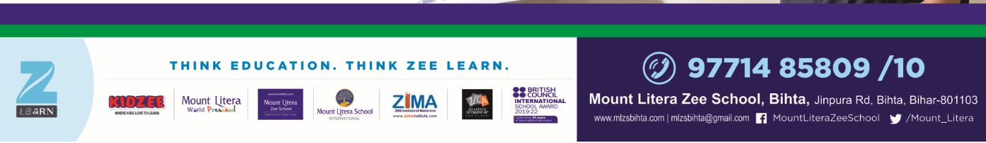

**Day Bording With SEP**

**Fee Details**

|  |  |  |  |
| --- | --- | --- | --- |
| ***Grade*** | ***SEP (with lunch)*** | ***SEP (without lunch)*** | ***Tuition Fee*** |
| ***III & IV*** | ***3200*** | ***2200*** | ***2400*** |
| ***V to VII*** | ***3200*** | ***2200*** | ***2900*** |
| ***VIII & IX*** | ***3800*** | ***2800*** | ***3250*** |
| ***X*** | ***3800*** | ***2800*** | ***3300*** |

***Note: The above-mentioned fee has to be paid monthly. Transport fee shall be applicable as per***

***distance/stoppage.***

***If any outsider student wants to get enrolled in the SEP after regular school hours***

***Grade VI to VIII – 24,000 (Can be paid in 2 equal halves)***

***Grade IX & X - 25,000 (Can be paid in 2 equal halves)***